**2nd Grade Student Supply List 2019-2020**

|  |  |
| --- | --- |
| *Boys*  Clorox Wipes  2 Boxes of Tissues  1 Ream Colored Printer Paper  Post-its (various sizes) | *Girls*  1 Box Quart Size Ziplock Baggies  1 Box Gallon Size Ziplock Baggies  1 Ream White Cardstock  1 Package of Baby Wipes |

**All Students Need:**

1 Personal Pencil Box- Please fill with the following items and label with your name (crayons and colored pencils-twistable only, scissors, pink eraser). This box is for personal use in the classroom. 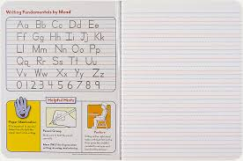

1 Earbuds/Headphones

1 Choice Folder-Label with students name

*Everyone: For Community Use*

* 2 Package of Elmer's Glue Sticks-No jumbo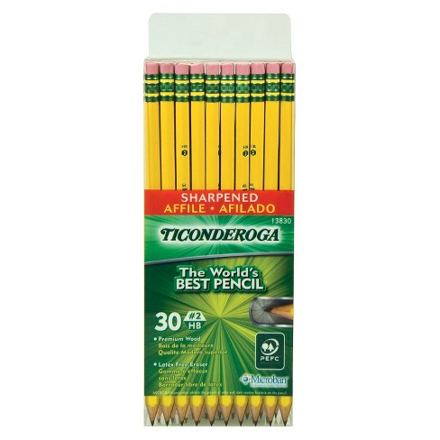
* 2 Packages Tycondaroga Pencils-pre sharpened-See photo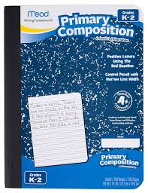
* 1 Box Expo Dry Erase Markers-Multi-color
* 2 Packages Pink Pearl Erasers
* 2 24 Pack Crayola Crayons
* 3 Pack Highlighters
* 4 Primary Composition Notebooks-See photo
* 1 Ream White Printer Paper
* 1 Bottle of Elmer's Liquid Glue

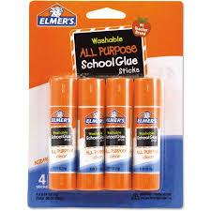

**$10 Cash** Donation for curriculum and science

supply materials

